**FPT International School**

--- o0o ---

**PROJECT REPORT**

**<Bookstore >**

Semester: 2

Group: 3

PHAM TUAN NGOC

DAM HUY ANH QUAN

DO HOANG MINH TUAN

DUONG DUC VINH

NGUYEN DAC TIEN

**Hanoi - 10/2022**

**Table of Contents**

[1.](#_gjdgxs) Problem Definition 3

[i.](#_gjdgxs) Introduction 3

[ii.](#_30j0zll) Implementation Environment 3

[User Stories 4](#_1fob9te)

[1.2](#_1fob9te)  Admin 4

[i.](#_3znysh7) Story 1 4

[ii.](#_2et92p0) Story 2 4

[iii.](#_tyjcwt) Story 3 4

[iv.](#_3dy6vkm) … 4

[1.3](#_1t3h5sf) User type 2 (Example: Staff) 4

[i.](#_4d34og8) Story 1 4

[ii.](#_2s8eyo1) Story 2 4

[iii.](#_17dp8vu) … 4

[2.](#_1y810tw) Database 5

[2.1](#_1y810tw) DB Relationship Diagram 5

[3.](#_1pxezwc) UI\UX 7

[3.1](#_1pxezwc) GUI 1 (Example: Login Form) 7

[3.2](#_49x2ik5) GUI 2 (Example: Address Book Form) 7

[3.3](#_2p2csry) GUI 3 8

[3.4](#_147n2zr) … 8

[3.5](#_3o7alnk) … 9

3.6 9

3.7... 9

3.8 9 4. Flowchart 9

4.1... 9

4.2... 9

[4.3](#_2grqrue) ... 9

4.4….. 4.5…4.6.. 10

# 

# Problem Definition

### Introduction

ABC is a great and essential book selling website for everyone. With the great development of scientific technology, buying books online is becoming more and more popular and chosen by many people. Not only does it save people time, it also helps people find books faster. To serve this urgent need, we have launched a website where everyone can access to buy books and learn about books.

They have approached you for website design and similar requirement specification is given below:

Website will be developed for Windows Platform using HTML5, JavaScript and Geolocation. The site will work fine on all the leading browsers including Chrome, IE, Firefox, etc.

### Implementation Environment

* HTML/ CSS/ JavaScript
* Boostrap / Jquery/ Boostrap
* MYSQL / PHP LARAVEL
* PHP STORM / GITHUB/ XAMPP/ CHROME

# User Stories

## Admin

#### +) Register

#### +) Manage Products

#### +) Manage Categories

#### +) Manage Users

### 

### Customers

#### Search Product

#### View Product

#### Purchase Product

# Database

## DB Relationship Diagram

# C:\Users\Dell\Pictures\Saved Pictures\310070336_2239684139546094_3382990575604054297_n.pngUI\UX

## GUI 1 ( Login Form)

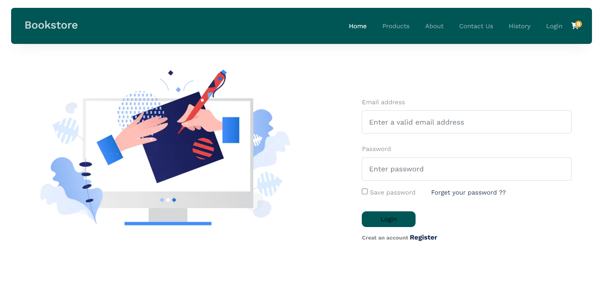

GUI 2 (HOME PAGE FOR BOOKSHOP)

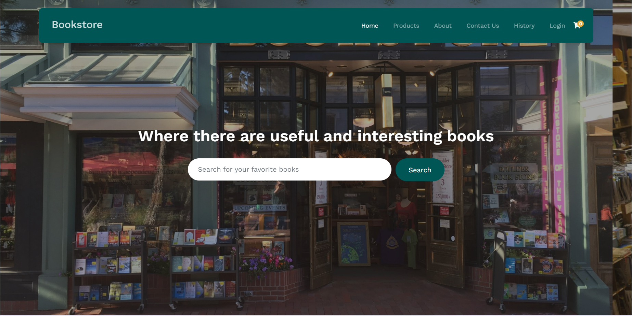

GUI 3 (SIGN UP))

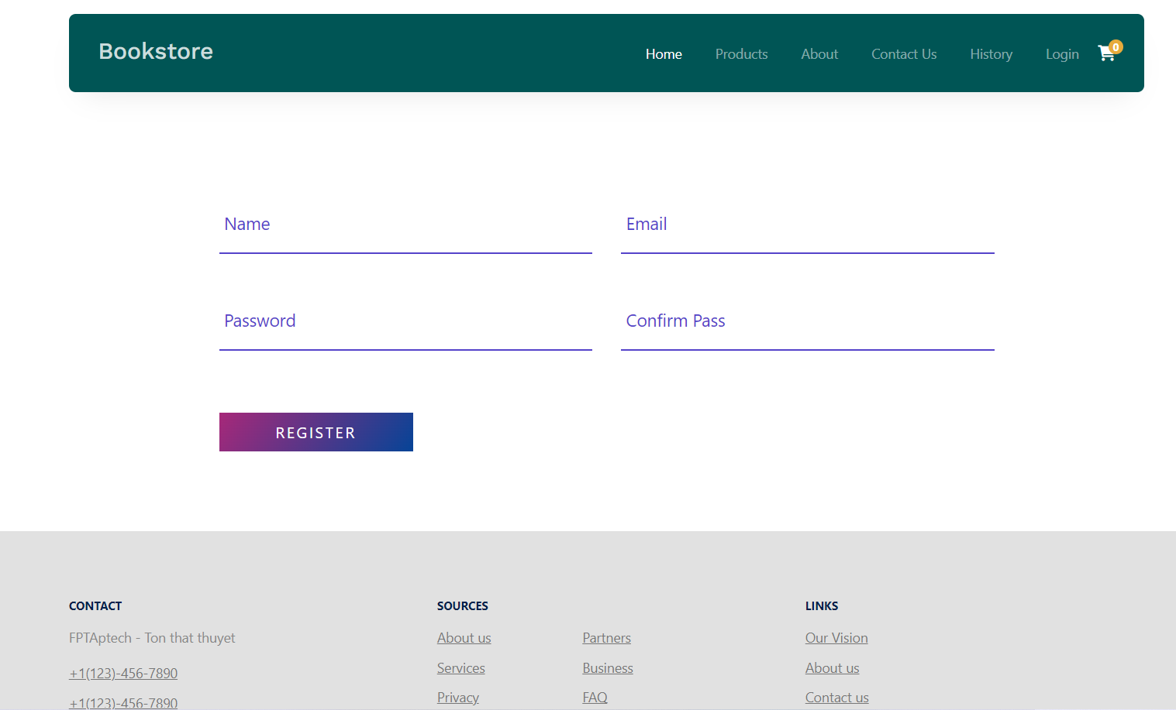

GUI 4 (ORDER)

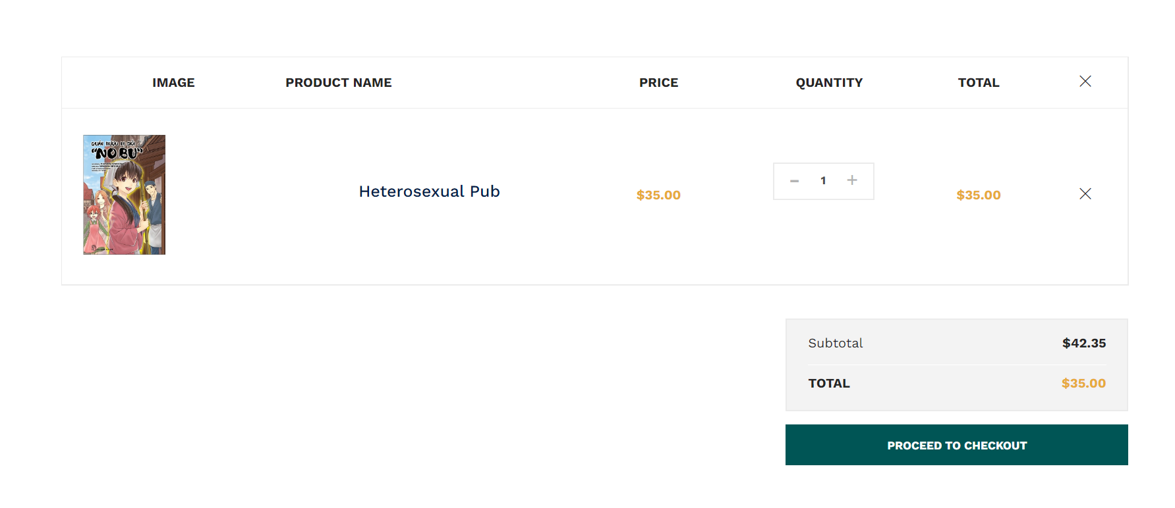

## GUI5 (About Us)

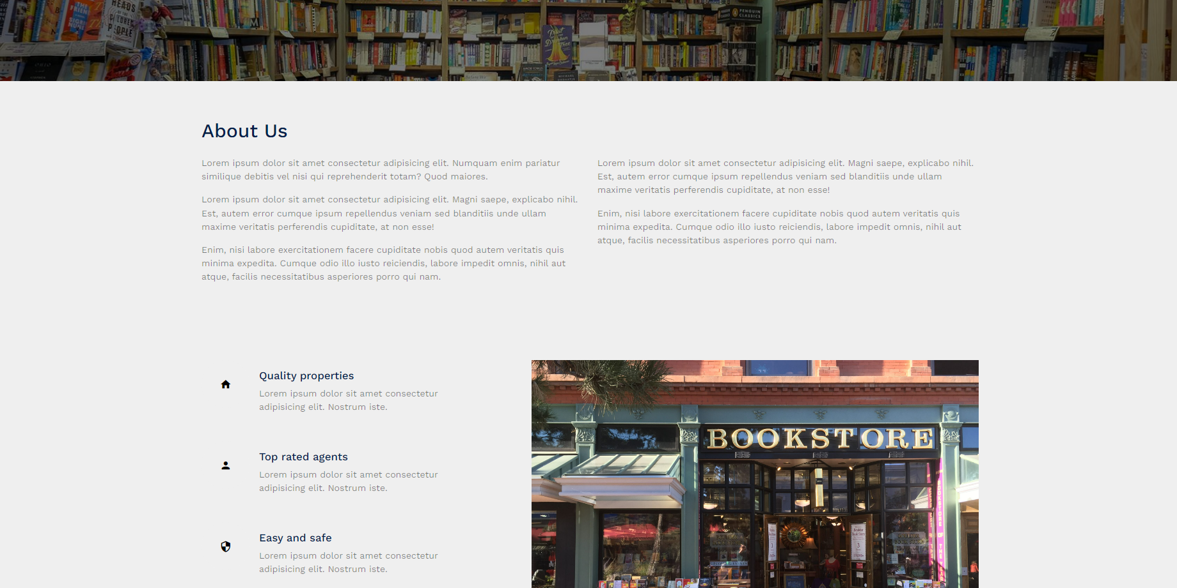

## GUI 6( Contact Us )

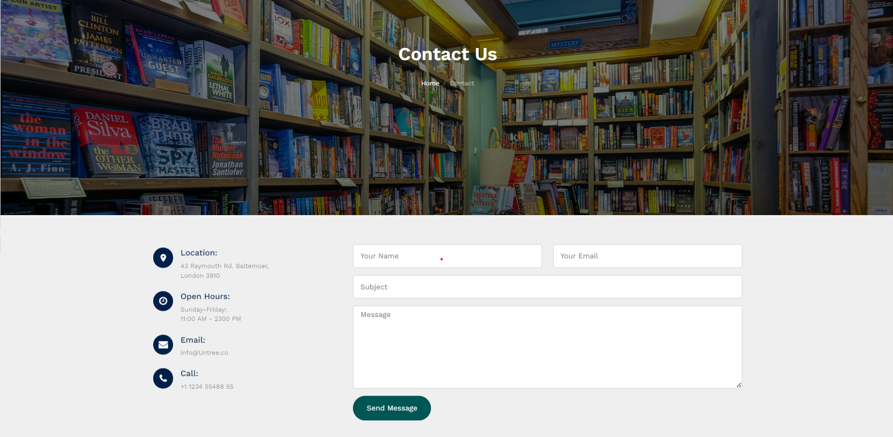

## GUI 7(Products)

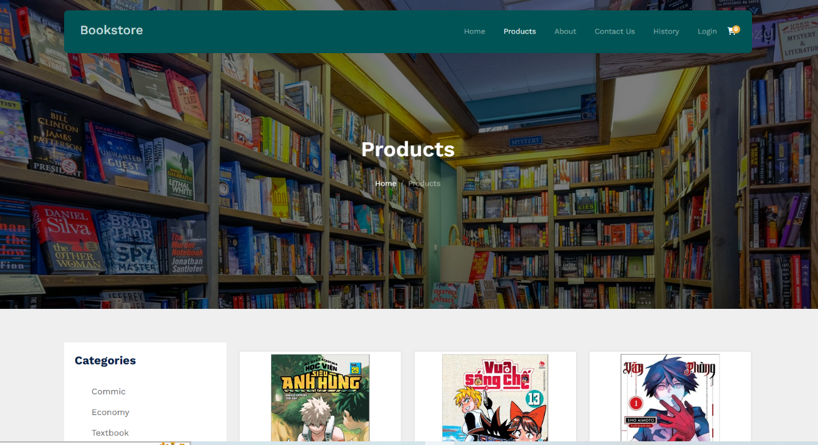

## GUI 8 ( Products detail)

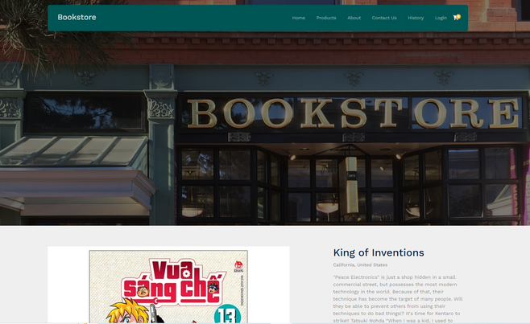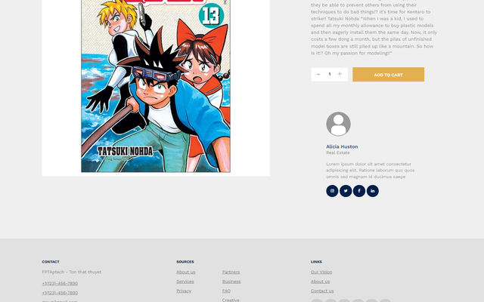

# Flowchart

## Register

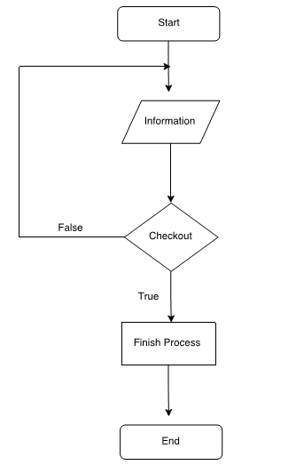

## Manage Product

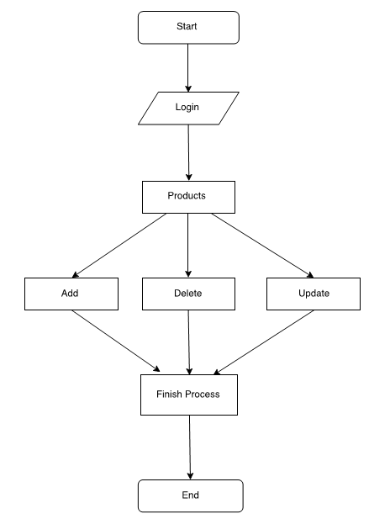

## Manage Categories

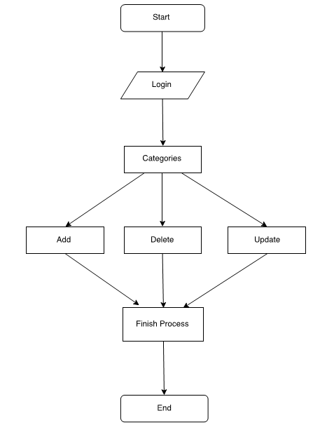

## 4.4 Manage Users

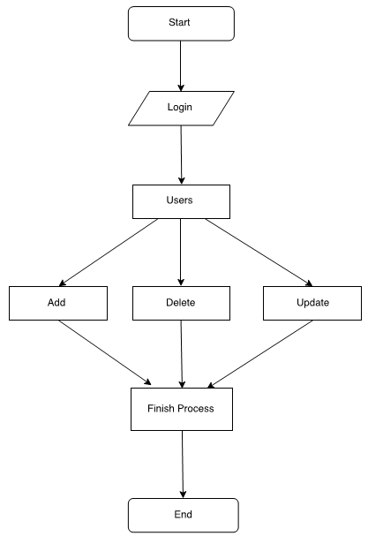

## Search Products

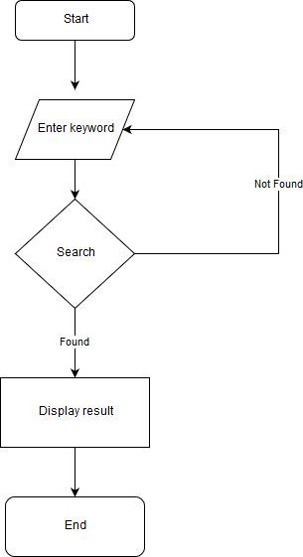

## Purchase Products

